

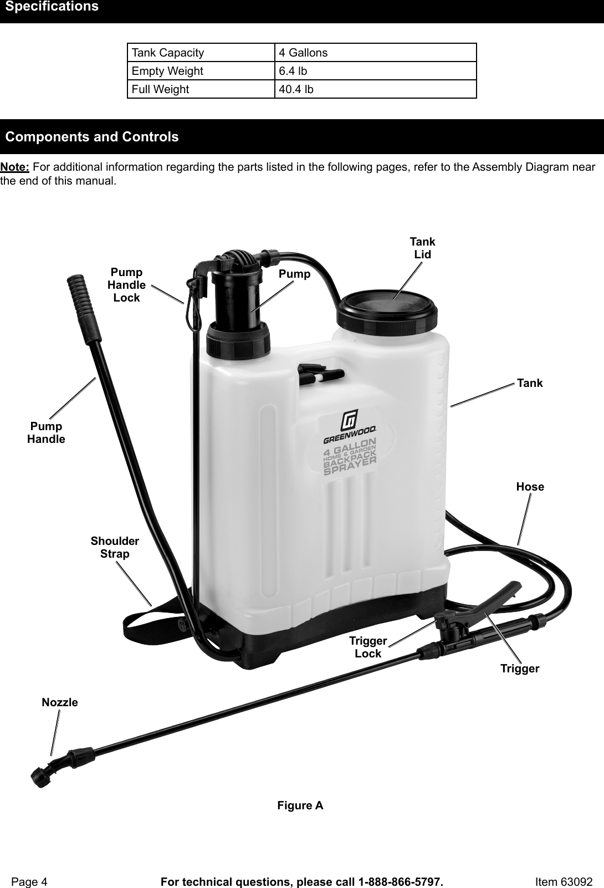



**PARTS OF A MOLDBOARD PLOW**

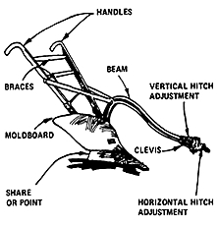

Arrow root

Maranta arundinacea

Cassava

Manihotesculenta

Sweet potato

Ipomoea batatas

Ubi

Dioscoreaalata

Fiber Crop...COMMON NAME
Cereals

SCIENTIFIC NAME

Rice

Oryza sativa

Corn

Zea mays

Sorghum
Wheat

Sorghum bicolor
Triticum aestivum...

Arrow root

Maranta arundinacea

Cassava

Manihotesculenta

Sweet potato

Ipomoea batatas

Ubi

Dioscoreaalata

Fiber Crop...

Coconut

Cocosnucifera

Peanut

Arachishypogaea

Sunflower

Helianthus annuus

Sugar Crop

Sugar beet

Beta vulgaris

Suga...

Cacao

Theobroma cacao

Coffee

Coffeaarabica

Spices, condiments, essences

Black pepper

Piper nigrum

Lemon grass

Andr...

Papaya

Carica papaya

Rubber

Heveabrasiliensis

Medicinal crops

Bitter gourd

Lagundi

Momordicacharantia

Vitexnegundo...

Tomato

Upo

Solanumlycopersicum

Lagenariasiceraria

Fruit crops

Banana

Musa acuminata

Durian

Duriozibethinus

Mango
...

King-offlowering-trees

Saracadeclinata

Mussaenda

Mussaendaphilippica

Royal palm

Roystonearegia

Song-of-india

Dracae...